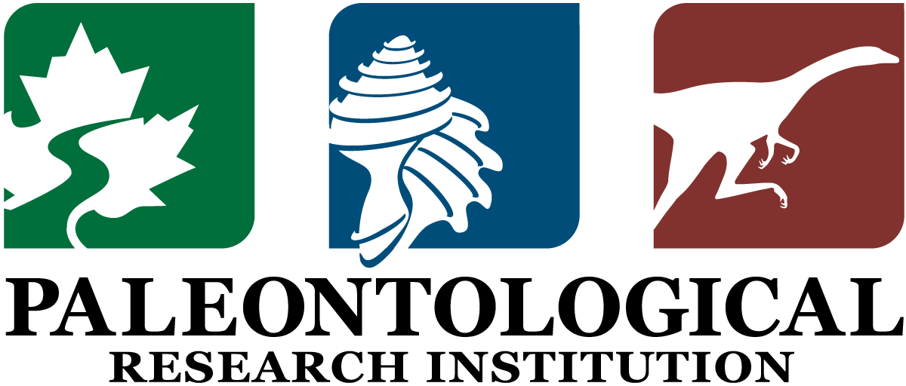

Bulletins of American Paleontology: Ethics Form

The Board of Trustees of the Paleontological Research Institution’s (PRI) Board of Trustees recognizes that works submitted for publication in PRI’s Bulletins of American Paleontology (BAP) must meet the highest ethical standards to be accepted for publication:

- Relevant to the science of paleontology, this means that all specimens were collected—and, when relevant, exported—ethically and in accordance with all relevant laws, and that no harm came to people, nor any significant impact was made to the environment because of their collection.

- Relevant to scholarship, this means that manuscripts must be free of fabricated data or information; be completely original; be free of plagiarism; and all sources of information must be appropriately credited and cited. All images must also be original, unless explicit permission from another publisher has been attained by the authors for their reuse.

Each author listed on a manuscript must complete the form below before their manuscript will be accepted for publication. Completed forms may be sent to the Editor either as scanned PDFs or mailed hard copies.

Please direct any concerns that you may have regarding this form, or matters that may arise while completing this form, to both the Editor of BAP and the Editorial Board (contact names and email addresses available at https://www.priweb.org/blog-post/bap-information)

Manuscript title:

Author name (each author completes their own form):

Part 1: Collection Ethics

1a. Did you collect any of the fossil or modern material described, figured, or otherwise included in the manuscript under consideration for publication in the Bulletins of American Paleontology (BAP)?

Yes (go to 1b). No (go to Part 2).

Not applicable (e.g., manuscript does not reference significant specimen material).

1b. If you answered “yes” to 1a: To the best of your knowledge, was the material described, figured, or otherwise included in the manuscript under consideration for BAP collected legally in accordance with all applicable, local, regional, state, or government laws and permitting requirements, regardless of country?

Yes. If a permit was issued, please provide the permit number in the Acknowledgments section of the manuscript.
No or unsure.

1c. If the material (fossil or modern) included in this manuscript for Bulletins of American Paleontology was collected in another country, was it—to the best of your knowledge—legally exported from that country in accordance with all applicable, local, regional, state, or government laws, regardless of country?

Yes. No or unsure.

1d. To the best of your knowledge, was the material described, figured, or otherwise included in the manuscript under consideration for BAP ethically and responsibly collected, meaning that no harm to people or significant impact on the environment resulted from collection of the material?

Yes. No or unsure.

1e. If the material (fossil or modern) included in this manuscript for Bulletins of American Paleontology was newly collected, has it been—or will it be by the time of publication—permanently deposited in a museum or other permanent collection that allows public access? Note that the Editor and/or PRI’s Science Committee reserves the right to contact museums listed in the manuscript to confirm that the corresponding material has been deposited.

Yes. No or unsure.

Note: Museum catalog numbers should be provided with descriptions and illustrations in the manuscript at the time of submission.

Part 2: Publication Ethics

2a. Are the portions of the manuscript that you contributed as an author or co-author free from fabricated data or other falsified results?

Yes. No or unsure.

2b. Are the portions of the manuscript that you contributed as an author or co-author fully original and free of plagiarism and light paraphrasing (i.e., just changing a few words “here and there”)?

Yes. No or unsure.

2c. Have all sources of outside information been appropriately credited and cited in the portions of the manuscript that you contributed as an author or co-author?

Yes. No or unsure.

2d. Are all images that you contributed for this manuscript original or have you attained permission (if necessary) from the original publisher for their re-use here?

Yes. No or unsure.

Note: Attaining permission for re-use (including payment of any associated fees) is the responsibility of the author(s). Slightly modifying a previously published image is not a substitute for attaining permission from the publisher for re-use. Rules and procedures for re-use of images vary considerably. Authors must attain necessary permissions—and provide proof of such re-use permissions to the Editor—prior to acceptance of the publication.

3. If you answered “no or unsure” to any of the items above, please provide an explanation of that/those answer(s) here. An answer of “no or unsure” will prompt a review by the Editor and may result in follow-up questions or rejection of the manuscript.

I answered “yes” to all items above.

4. Please provide a statement of your individual contribution to the manuscript under consideration for publication in Bulletins of American Paleontology.

5. To the best of your knowledge, did other individuals, not listed as authors, make substantial material or intellectual contributions to this manuscript?

Yes. No.

6. Please read and then sign to indicate that you agree with the following statement:

I attest that the answers provided above are, to the best of my knowledge, true and accurate, and understand that untruthful or inaccurate answers may be grounds for rejecting this manuscript from consideration for publication in Bulletins of American Paleontology.

Author’s Name:

____________________________________________________

Signature required

